**For Fronent-end**

Url- <https://github.com/simpy-surbhi/Sales-Customer-Survey-Frontend>

Visual Studio Code

ReactJS

Install Npm

**For Backend**

URL- <https://github.com/simpy-surbhi/Sales-Customer-Survey-Backend>

Visual Studio 2015

Asp.Net C#

Sql Server

WebAPI

**SQL Server**

Create Database Customer

Create Table CustomerSurveyTable

Below Table Column Name

[Id],[Age],[Gender],[Drivinglicense],[Firstcar] Drivetrain],[Fuelemissions],[NoOfCar]

,[CarName],[CarModel]

* Id :Auto Incremented, Primary key
* Age ,CarName :Int
* Others Field : Varchar

**Screenshot**

**Customer Survey Page**

* Every Field has Validation

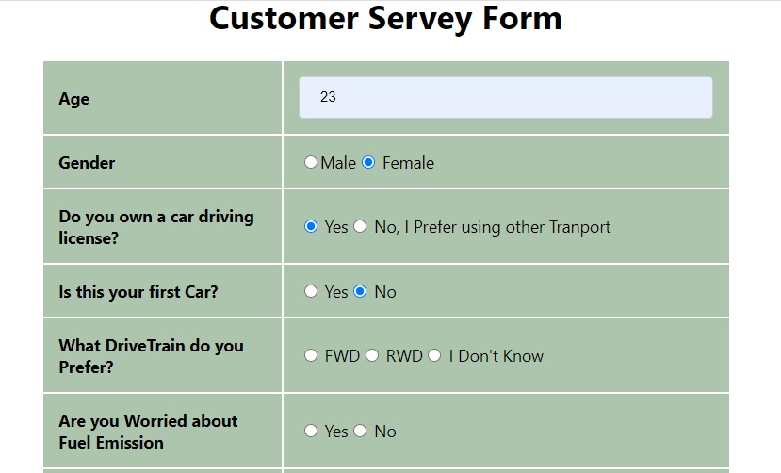 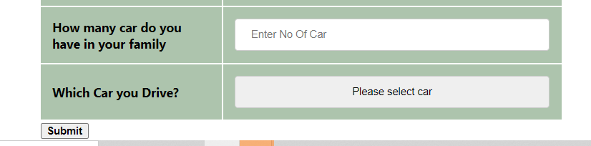

**Analysis Page**

Url : <http://localhost:3000/analysis>

